- Display the list of employees who have joined the company before 30th June 80 or after 31st Dec 81.
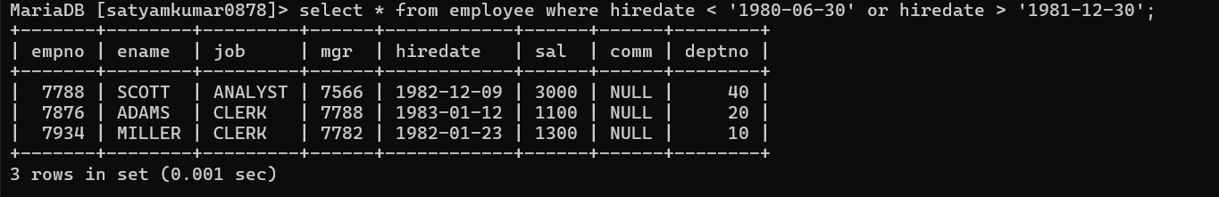
- Display the names of employees whose names have second alphabet A in their names.
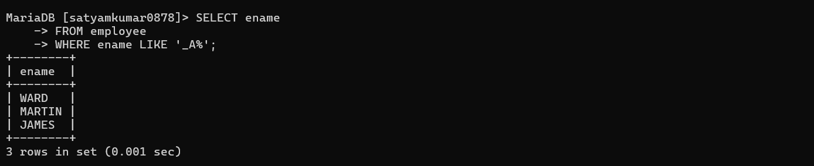
- Display the names of employees whose name is exactly five characters in length
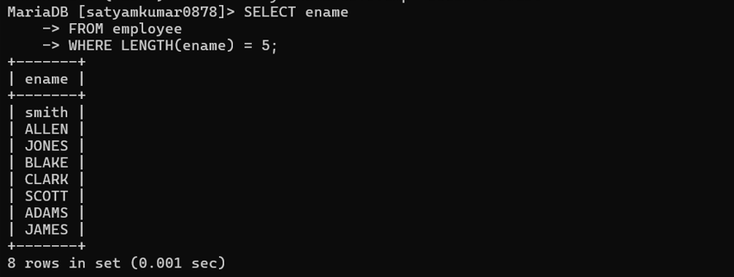
- Display the names of employees whose names have ends with ER in their names.
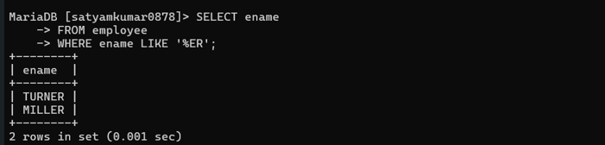
5. Display the names of employees who are not working as salesman or clerk or analyst.
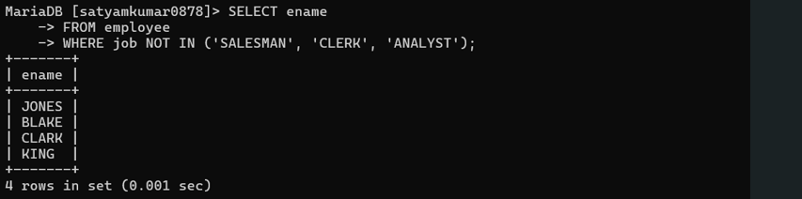
6. Display the name of the employee along with their annual salary (sal*12). The name of the employee earning highest salary should appear first.
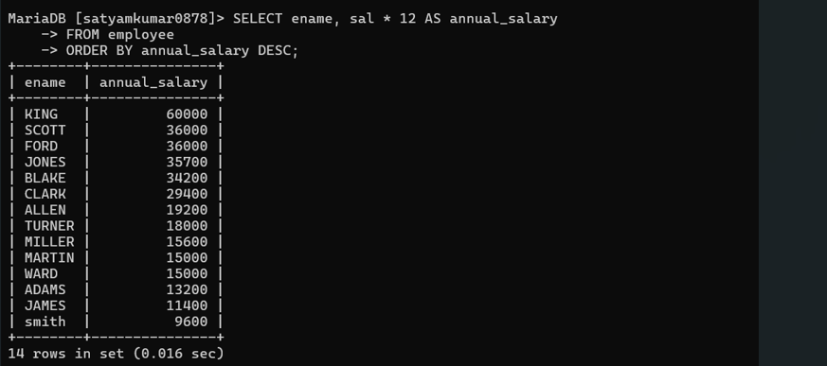
7. Display name, sal, hra, pf, da, totalsal for each employee. The output should be in the order of total sal, hra 15% of sal, da 10% of sal, pf 5% of sal. Total salary will be (sal*hra*da)-pf.
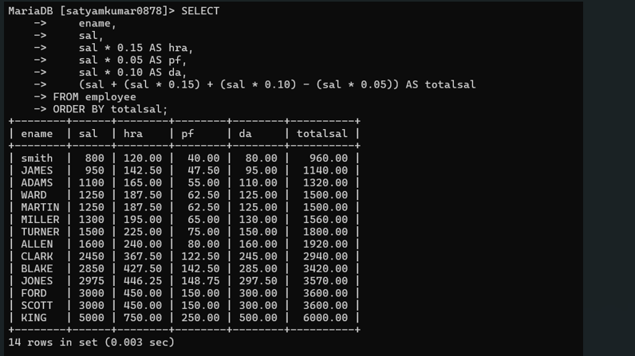

8. Update the salary of each employee by 10% increment who are not eligible for commission.
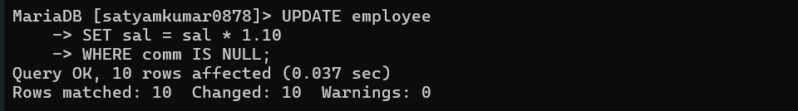

9. Display those employees whose salary is more than 3000 after giving 20% increment.
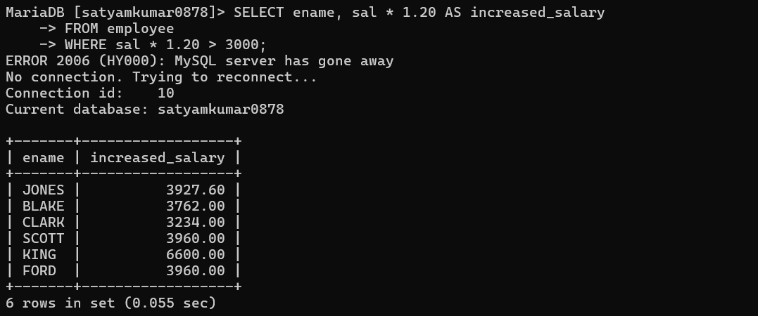
10. Display those employees whose salary contains atleast 3 digits.
